# E - Gram panchayat

Submitted in partial fulfillment of the requirements of the degree

**BACHELOR OF ENGINEERING IN** **COMPUTER ENGINEERING**

By

**Prerna Sunil Ingle (22)**

**Tejal Subhashrao Bhagat(04)**

**Gayatri Ram Padile (45)**

Name of the Mentor

**Prof.**  R. C. Suryavanshi



**Department of Computer Engineering**

**A. C. Patil College of Engineering**

**Kharghar, Navi Mumbai**

**University of Mumbai**

**(AY 2021-22)**

# CERTIFICATE

This is to certify that the Mini Project entitled **“ E - Grampanchayat ”** is a bonafide work of **Prerna Sunil Ingle (22), Tejal Subhashrao Bhagat (04), Gayatri Ram Padile (45)** submitted to the University of Mumbai in partial fulfillment of the requirement for the award of the degree of **“Bachelor of Engineering”** in **“Computer Engineering” .**

## (Prof. R. C. Suryavanshi)

(Project Guide/Mentor)

## Dr. M. M. Deshpande) Dr. V. N. Pawar

## Head of Department Principal

# Mini Project Approval

This Mini Project entitled “E - Grampanchayat**”** by **Prerna Sunil Ingle (22), Tejal Subhashrao Bhagat (04), Gayatri Ram Padile (45)** is approved for the degree of **Bachelor of Engineering** in **Computer Engineering.**

**Examiners**

**1………………………………………**

(Internal Examiner Name & Sign)

## 2…………………………………………

(External Examiner name & Sign)

Date: Place:

# Contents

## Abstract i

## Acknowledgments ii

## List of Abbreviations iii

## List of Figures iv

## List of Tables v

## Introduction 1

* 1. Introduction
  2. Motivation
  3. Problem Statement & Objectives
  4. Organization of the Report

1. **Literature Survey 11**
   1. Survey of Existing System/**SRS**
   2. Limitation Existing system or Research gap
   3. Mini Project Contribution

## Proposed System (eg New Approach of Data Summarization ) 18

* 1. Introduction
  2. Architecture/ Framework
  3. Algorithm and Process Design
  4. Details of Hardware & Software
  5. Experiment and Results for Validation and Verification
  6. Conclusion and Future work.

## 4 References 32

**Abstract**

This project is aimed at the developing an E-Gram Panchayat Management System (EGPMS).

EGPMS is an online based application that can be accessed throughout the internet. This System may be used for monitoring gram panchayat activities. Admin as well as body member’s logging, it may also access and public can search provided information regarding gram panchayat at any time. The Information about Schemes published by government or any other activities and billing record will be updated by body members and the secure data maintained by only administrator.

EGPMS is being developed for maintain and facilitate easy access to information. For this user don’t need to be registered. It is user friendly website, only admin has authority to give access or choose login members.

EGPMS is an online based application that aims to provide information keep the Records and Documents like birth certificates, death certificates, residential certificates, 7/12 certificates. Any user can access the data and download some information from database and only body members have authority to upload the data.

**i**

**Acknowledgement**

The completion of this project could not have been possible without the participation and assistance of a lot of individuals contributing to this project. We are highly indebted to our Prof. R. C. Suryavanshi for their great guidance and supervision. We would like to thank her for providing the necessary information and resources for this project. However, we would like to express our deep appreciation and indebtedness to our Head of Department (HOD) Dr. M. M. Deshpande and to our respected Principal Dr. V. N. Pawar for their endless support, kindness, and understanding during the project duration.

We would also like to thank our college for providing us all the necessary resources for the project. All in all, we would like to thank everyone involved in this project and helped us with their suggestions to make the project better.

**ii**

**List Of Abbreviations**

|  |  |  |
| --- | --- | --- |
| **Sr. No** | **Abbrevations** | **Full Form** |
| **1** | **GPMS** | **Gram Panchayat Management System** |
| **2** |  |  |
| **3** |  |  |
| **4** |  |  |
| **5** |  |  |
| **6** |  |  |

**List Of Figures**

1. Architecture/Framework

**List of Tables**

1. Survey of existing system
2. Future work

**iii**

**Chapter 1: Introduction**

**1.1 Introduction**

Under the National e-Governance Plan (NeGP) in 2006, the government planned to introduce technology to improve efficiency in the functioning of gram panchayats in India. In 2018, the e-panchayat mission was launched by the Ministry of Panchayati Raj, as a component of the Mission Mode Projects (MMP) to meet this objective. The project covers all aspects of gram panchayats, including planning, monitoring, implementation, budgeting, accounting, social audit and civil service delivery of issuance of certificates, licenses, etc.

The objective of the e-panchayat mission is to enable panchayats to perform efficiently, through the extensive use of information and communication technology (ICT). Also, as the government endeavours to build a digitally-inclusive society, it is important that these grassroots institutions of public welfare make the best use of the technological tools available to them

**iv**

**1.2 Motivation**

Now a day’s people in the rural areas have to go to panchayat office in their location to apply and get their certificates provided in that office. It requires a lot of time and may result in work delay. The data in the office has to be maintained manually. There is no security for the data and faults can be encountered during entering the data mainly which require higher calculations. People also face so many problems in their area. They complain to their respective ward members but they may or may not respond quickly. There are many other problems in the present day panchayat raj system.

In a state where the gram panchayat has been able to fully adopt the e panchayat modus operandi, all the data and information about gram panchayats could be easily accessed through the internet. In states like Andhra Pradesh and Goa, where the e panchayat programme has been implemented to some extent, citizens can avail of certain facilities online. These include issuance of birth and death certificates, property tax, pension benefits, subsidy benefits, e-health care, e-learning and e-agricultural extension services, etc.

**v**

**1.3 Problem Statement and Objectives**

**Problem Statement:**

There is no security for the data and faults can be encountered during entering the data mainly which require higher calculations. People also face so many problems in their area. They complain to their respective ward members but they may or may not respond quickly. There are many other problems in the present day panchayat raj system.

**Objectives:**

* Automation of internal workflow processes of panchayats.
* Improving delivery of services to citizens.
* Capacity building of panchayat representatives and officials.
* Social auditing.
* Transparency, accountability, efficiency and RTI compliance of panchayats.
* Improving governance of the local self-government by ensuring people’s participation in decision-making.

**vi**

**1.4 Organization of the report**

The project report presented here is organized into four chapters.

After this introductory chapter,

chapter 2 describes the “Literature Survey” which reflects the Existing System Survey, for finding existing system’s limitations and Limitations of Existing systems.

Chapter 3 presents the brief description of the proposed system of the project which includes Introduction to proposed system, Architecture, Process design and Algorithm, Implementation and Conclusion with future work.

Chapter 4 describes the References

**vii**

**Chapter 2: Literature Survey**

**2.1 Survey Of Existing System**

people in the rural areas have to go to panchayat office in their location to apply and get their certificates provided in that office. It requires a lot of time and may result in work delay.

The data in the office has to be maintained manually. There is no security for the data and faults can be encountered during entering the data mainly which require higher calculations.

**2.2 Limitations of Existing System**

People face so many problems in their area. They complain to their respective ward members but they may or may not respond quickly. There are many other problems in the present day panchayat raj system. So, the E-panchayat provides solutions to all the problems in the current system.

**2.3 Mini project Contribution**

E-Gram-panchayat provides online service to the people living in that area. All the services which are done manually are made online in the project. The people can about their panchayat, activities notifications and all other information related their villages. All the applications and certificates are applied and verified online. The users on the people in the village can complain about their problem through online. Suggestions are also accepted from the people for the development of their village. The user can request any application like birth certificate, income certificate, etc.

.

**viii**

**Chapter 3: Proposed System**

**3.1 Introduction**

The e-panchayat program aims at equipping rural India with updated information online and thus, enables gram panchayats to be computer. For this purpose, the e-Panchayat MMP is aimed at automating internal work flow processes of approximately 2.45 lakh panchayats across India. This will cover approximately 30 lakh elected members and several lakh PRI functionaries.

In a state where the gram panchayat has been able to fully adopt the e panchayat modus operandi, all the data and information about gram panchayats could be easily accessed through the internet. In states like Andhra Pradesh and Goa, where the e panchayat program has been implemented to some extent, citizens can avail of certain facilities online. These include issuance of birth and death certificates, property tax, pension benefits, subsidy benefits, e-agricultural extension services, etc.

The objective of the e-panchayat mission is to enable panchayats to perform efficiently, through the extensive use of information and communication technology (ICT). Also, as the government endeavours to build a digitally-inclusive society, it is important that these grassroots institutions of public welfare make the best use of the technological tools available to them.

**ix**

**3.2 Architecture / Framework**

The Panchayati Raj system is a multi-tier system with elected bodies at the different levels. It was formulated to create greater participation in local government by people and more effective implementation of rural development programs. It intends to provide self-governance, make sure that spending for public welfare reaches the people and improve the performance of grass root functionaries. To provide these intended benefits to the citizens, increase efficiency and improve governance, the PRI organization structure has evolved into two basic models: 3-tier,and 2-tier. The type of model implemented by the State varies based on the geographical, political & demographical factors present in the State and is defined in the State Panchayti Raj act of respective state

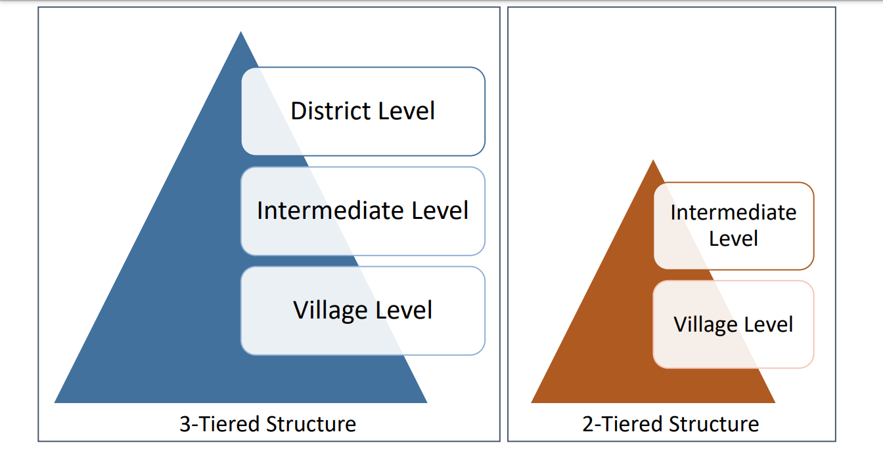

**x**

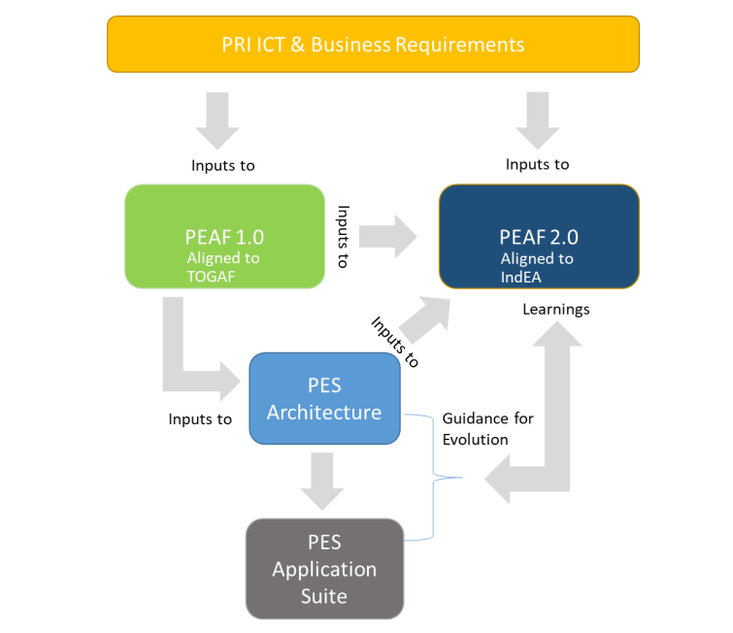

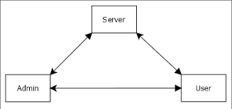

**Architecture/Framework**

**xi**

**3.3 Algorithm and Process**

**xii**

**3.5 Details of Hardware and Software**

**Hardware**

1. Laptop / Desktop
2. RAM: 4GB or more
3. Processor: Intel Pentium or Higher Processors
4. Webcam
5. Internet Connection

**Software**

1. Operating System: Windows 7,8,10 or higher
2. Languages: CSS, PHP, HTML
3. Platform:

**xiii**

**3.6 Experiment and Results for Validation and Verification**

The portal was successfully tested on the previously specified testing dataset with a accuracy of 91.58%, this is a considerably good accuracy when compared to a similar to different portal.

When building this particular portal. We have to research about panchayat then we make this portal on basis of research and provide the portal on goggle that helps people

**Results**

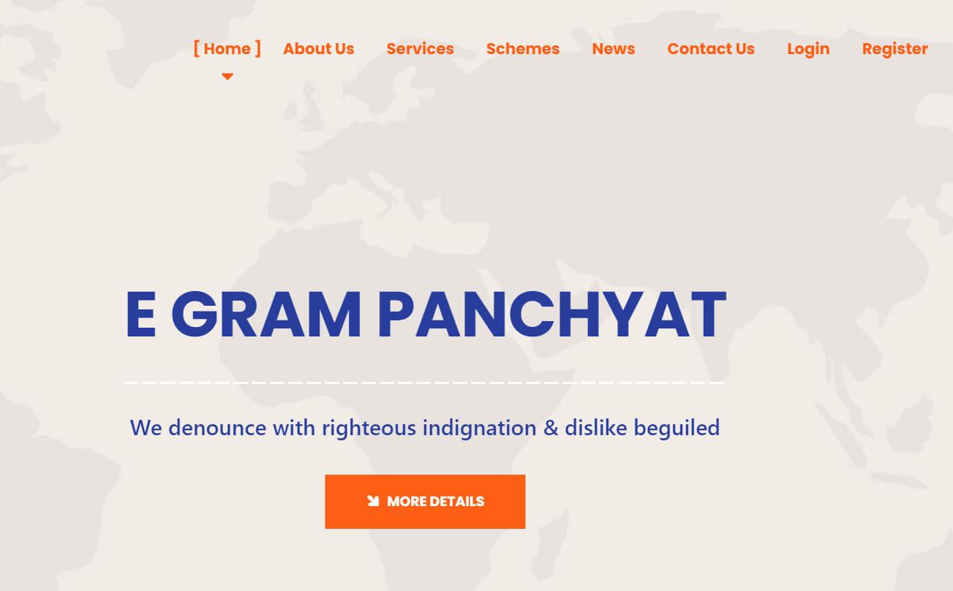

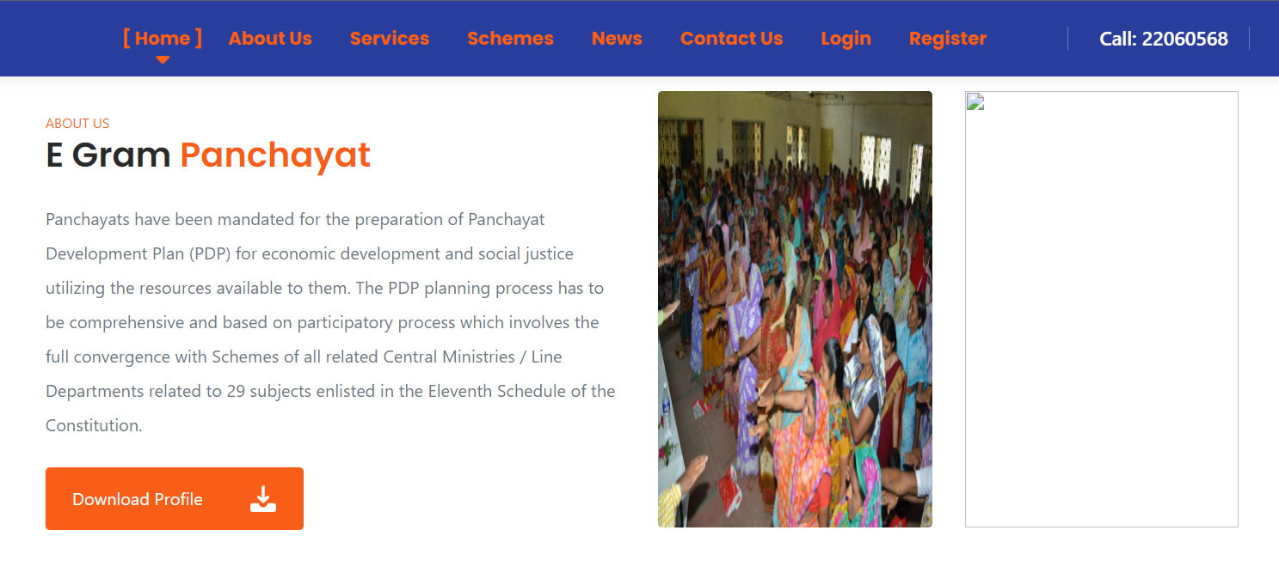

**Services provided by panchayat in user login**

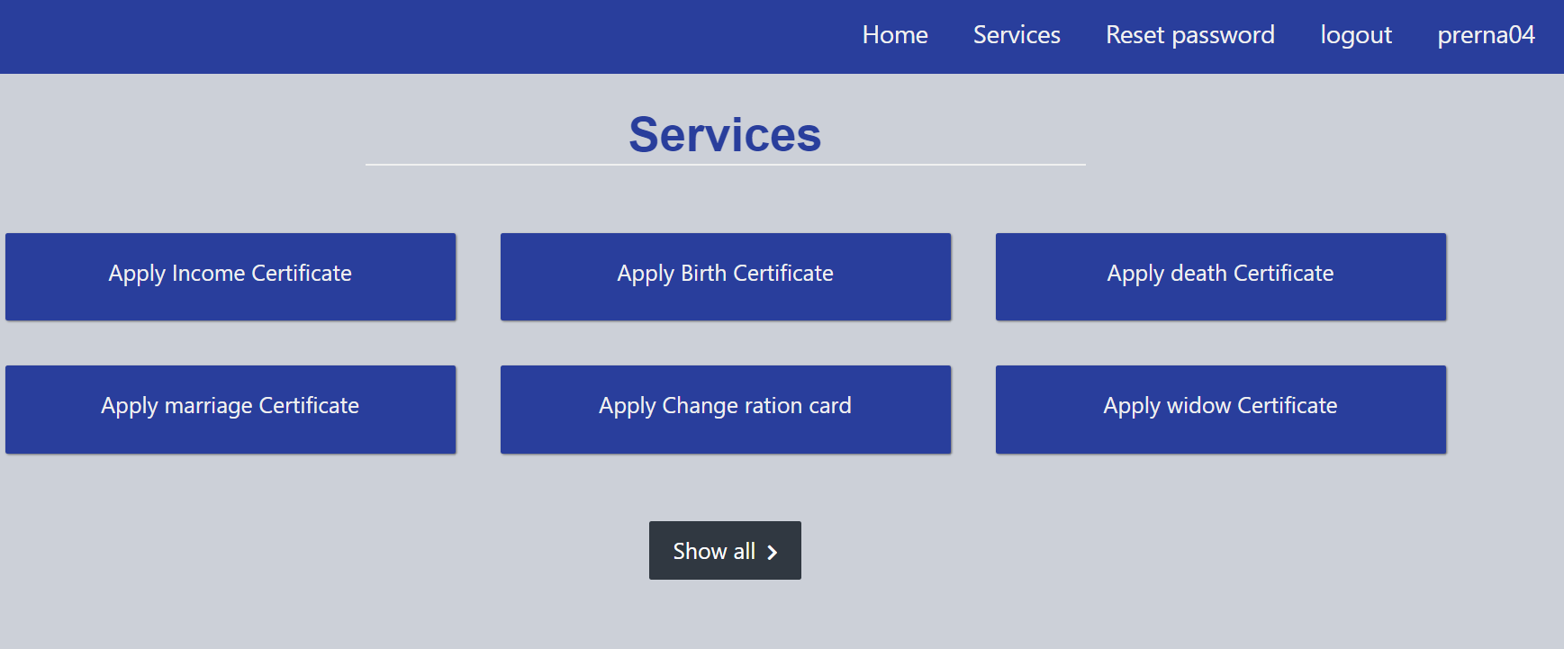

**Admin panel of panchyat**

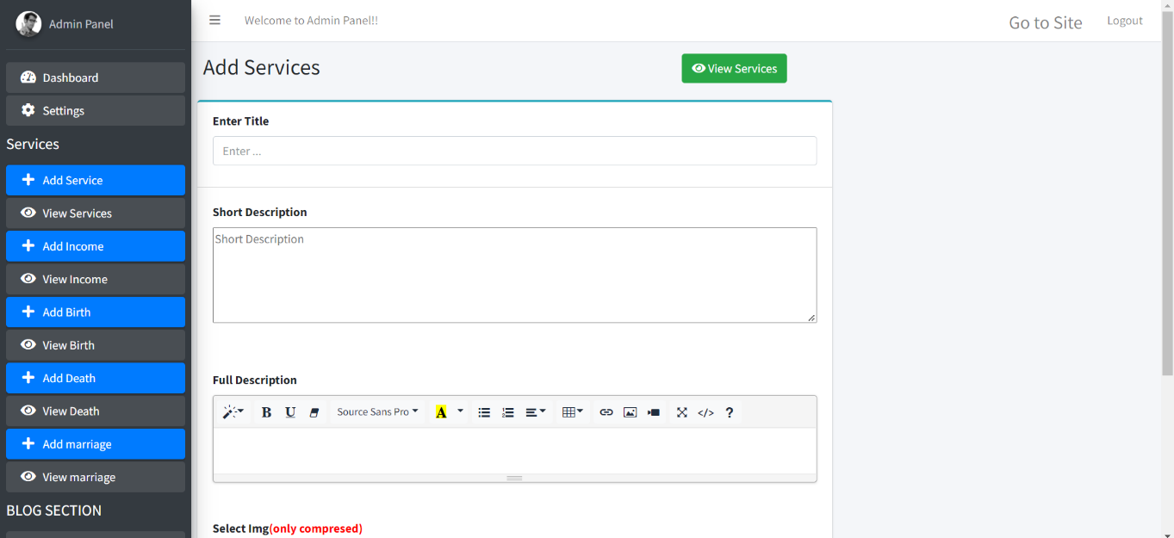

**xiv**

**3.7 Conclusion and Future work**

In spite of the rapid urban in India, nearly 70% of the country’s total population still resides in villages. This makes the role of gram panchayats, which lie at the lowest level of Panchayat Raj institutions, crucial, in terms of nation-building.

1. Governance for panchayat provides online services to the people living in that panchayat. It helps for the people in that area to easily complete their work which involves the action of authority of the panchayat people. As everything is made online people can request their applications from anywhere at any time. After requesting the certificate the process will be carried out normally, no need for the people to go to panchayat office every time for the completion of work. It saves people time and they can perform their daily work without any interruption.

|  |  |
| --- | --- |
| **Objectives** | **TO enable E-Grampanchayat to perform efficiently through extensive use of ICT.** |
| **Implementation** | **Planning, Monitoring, Implementation, Social audit and civil services delivery ,of issuance of certificates, license, etc.** |

|  |
| --- |
| 1. **Grampanchayat : Key Facts** |

**Reference**

[1] Ch. Leela Poornima, Ch. Pavani, G. Parameswari, K. Subhash Reddy, “Automation of Gram Panchayat”, International Journal of Emerging Trends in Engineering Research, 2016.

[2 ] Amit N. Sangole, S. A. Bhura, “Sustainable Development of Grampanchayat through E-Governance”, International Journal of Computer Science and Information Technologies, 2016.

[3] Prof. S. D. Dhage, Prof. G. A. Ghone, Akash R. Bhojane, Prathamesh B. Thorat, Naim Y. Shaikh, “E-Gram Panchayat Management System”, International Journal for Scientific Research & Development, 2018

* <https://www.computervision.zone/>
* [https://google.github.io/mediapipe/](https://www.computervision.zone/)
* [https://www.w3schools.com/python/](https://www.computervision.zone/)
* https://www.youtube.com/